Team 64

Fall 2023 Principles of Info. Systems (SITE-1101 – 10409)

Team members: Jalal Mammadov; Ruzgar Turhan; Javid Aghayev; Shukur Ismayilov

HW 3

Contribution table:

|  |  |  |
| --- | --- | --- |
| Team member | Contribution to the project | Estimated % |
| Jalal Mammadov | Website maker, html checker | 33% |
| Javid Aghayev | Website maker, css checker | 33% |
| Rüzgar Turhan | Website maker,  Js checker | 33% |
| Shukur Ismayilov | Who did nothing at all | 1% |

**The Urls of Mammadov Jalal**

<https://www.codecademy.com/profiles/MammadovJalal>

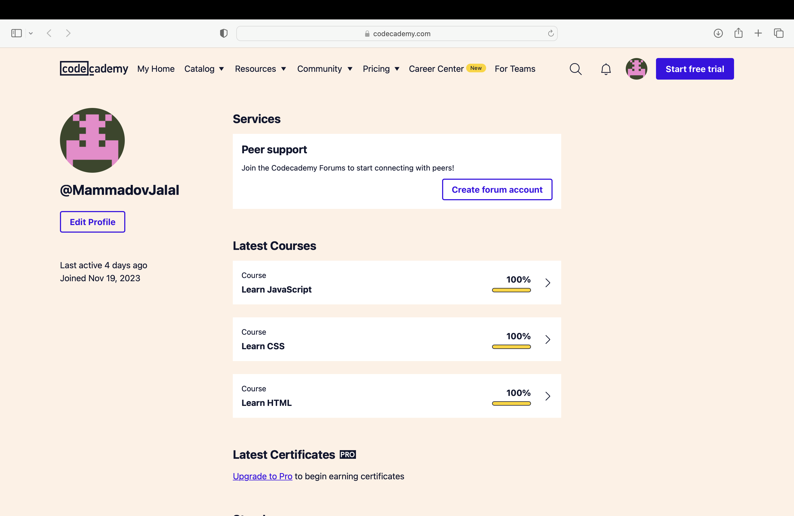

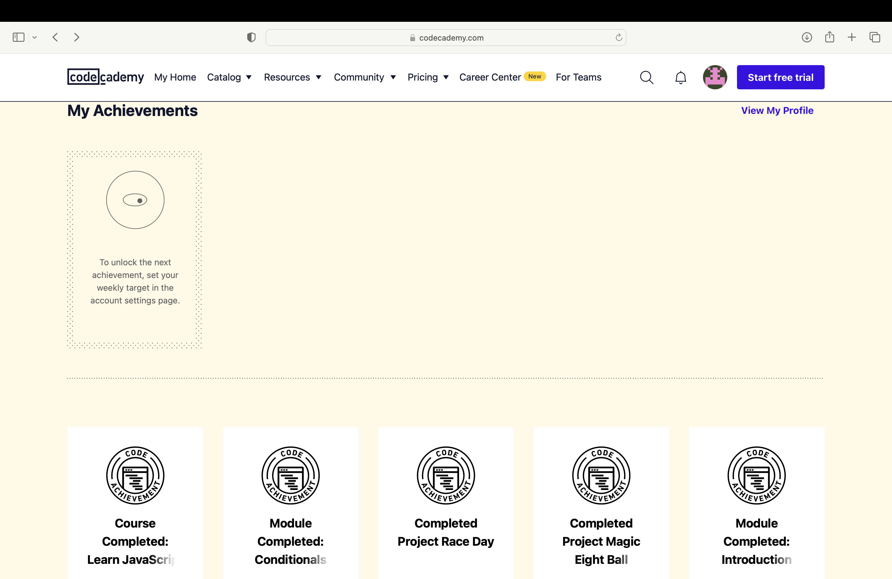

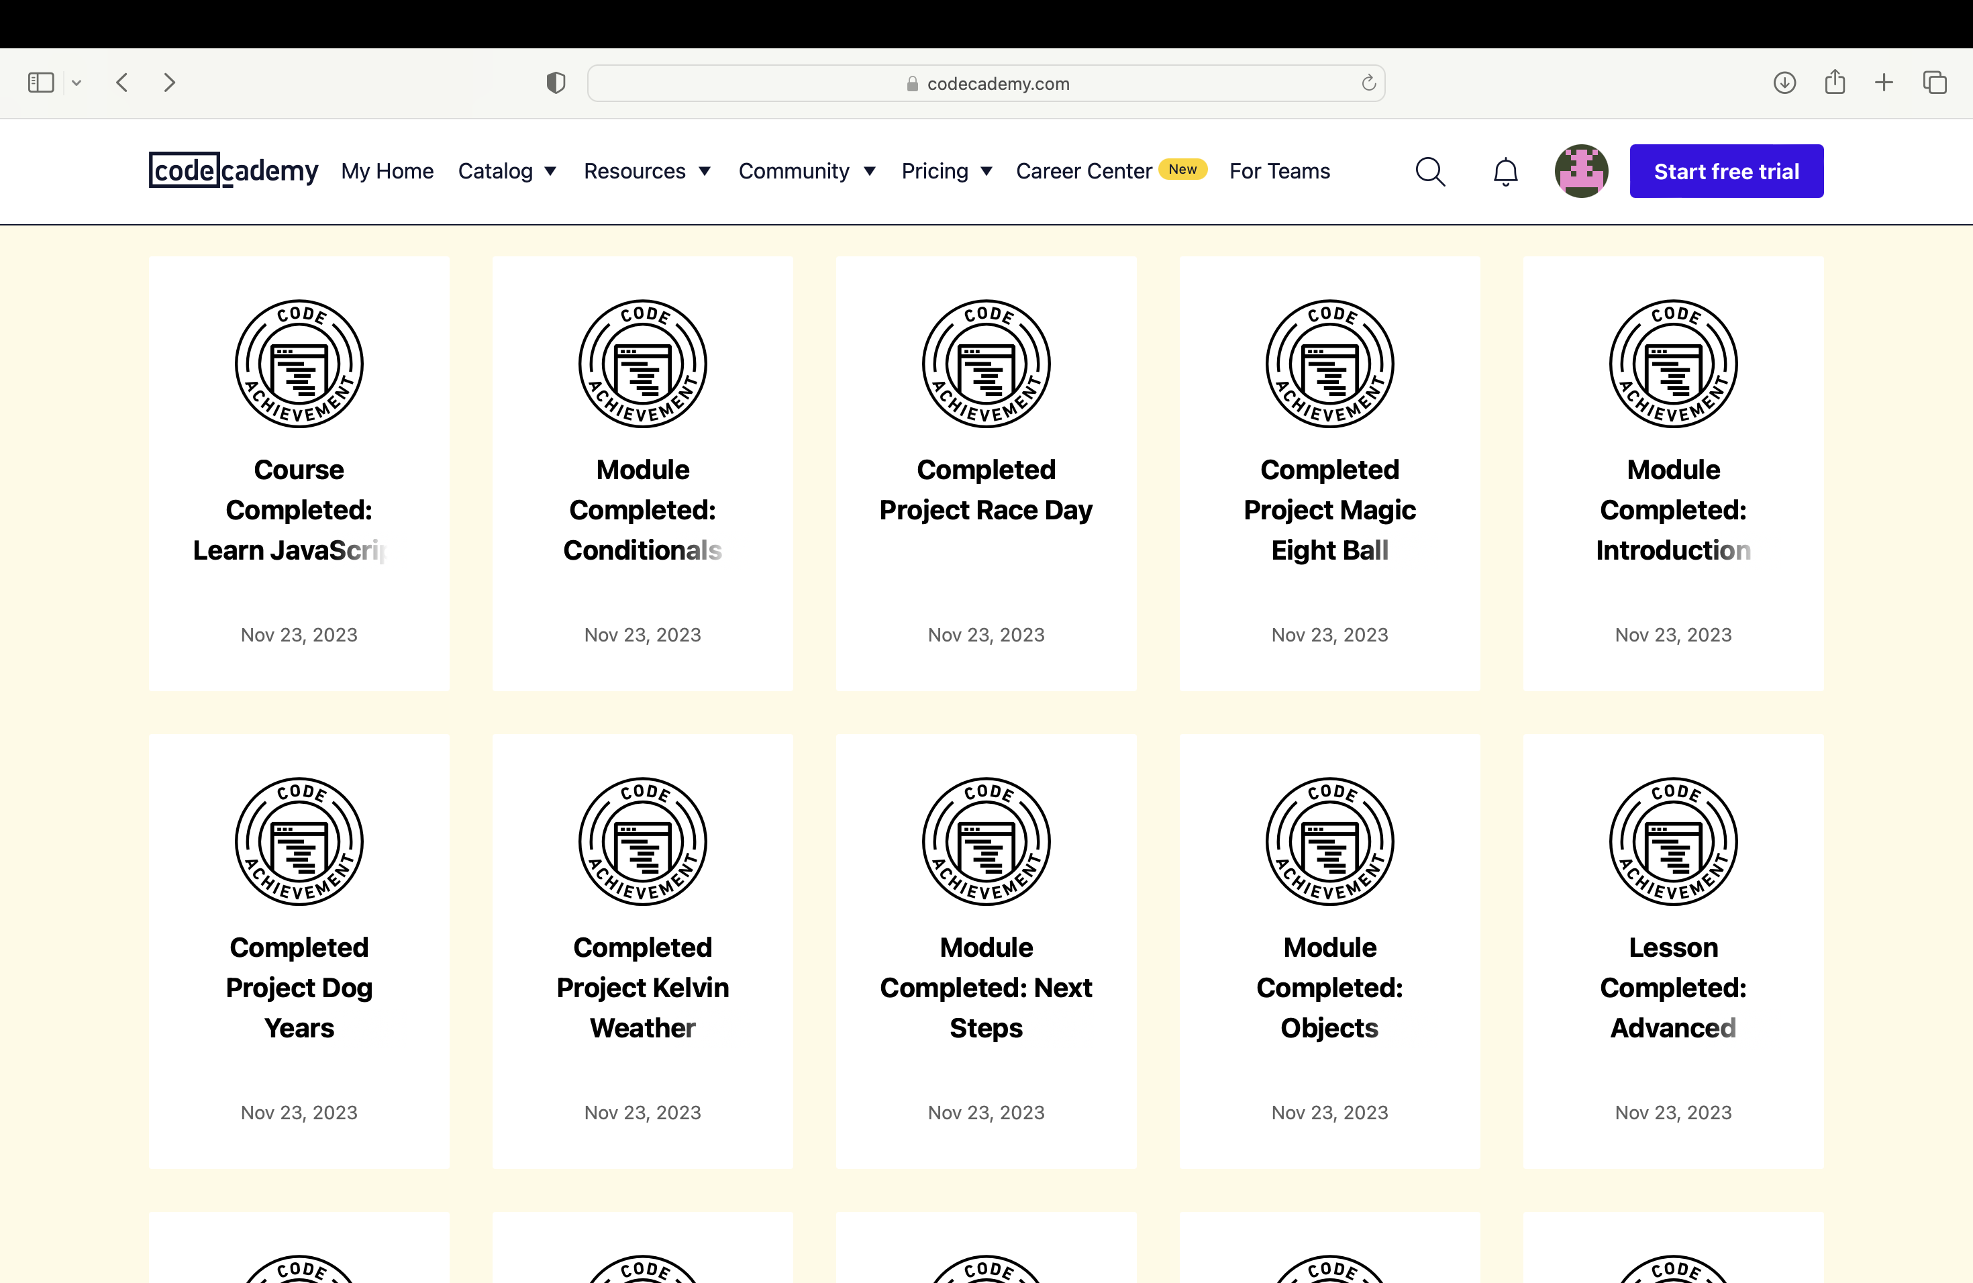

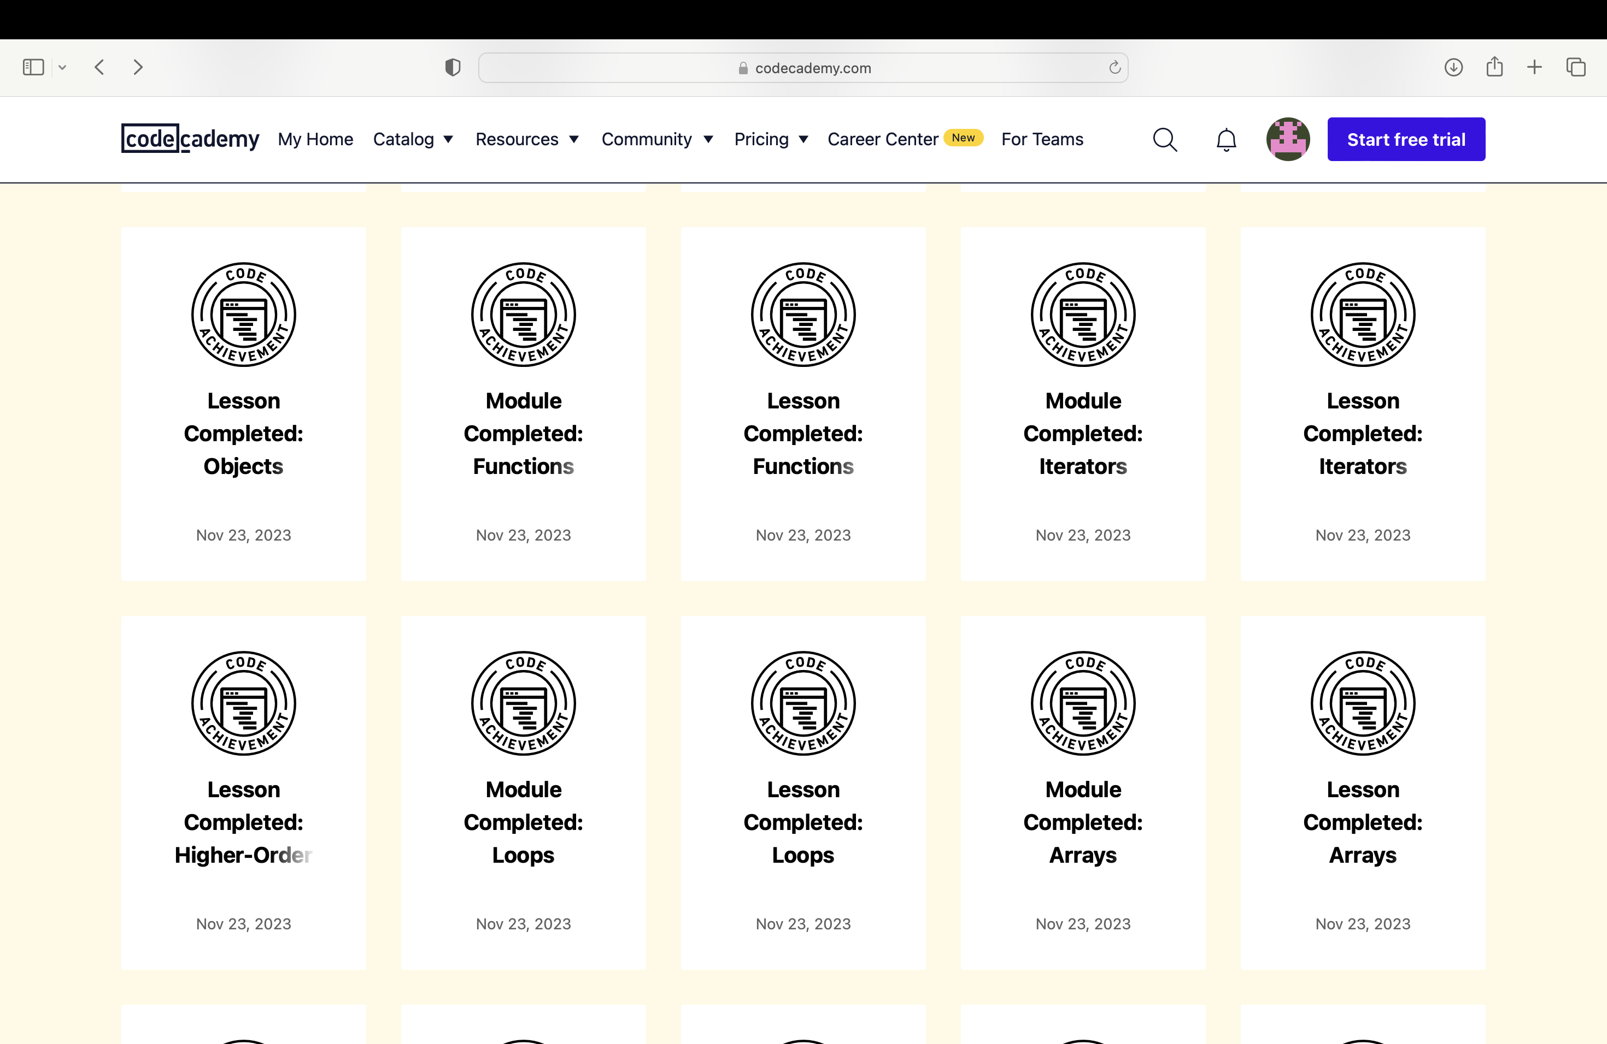

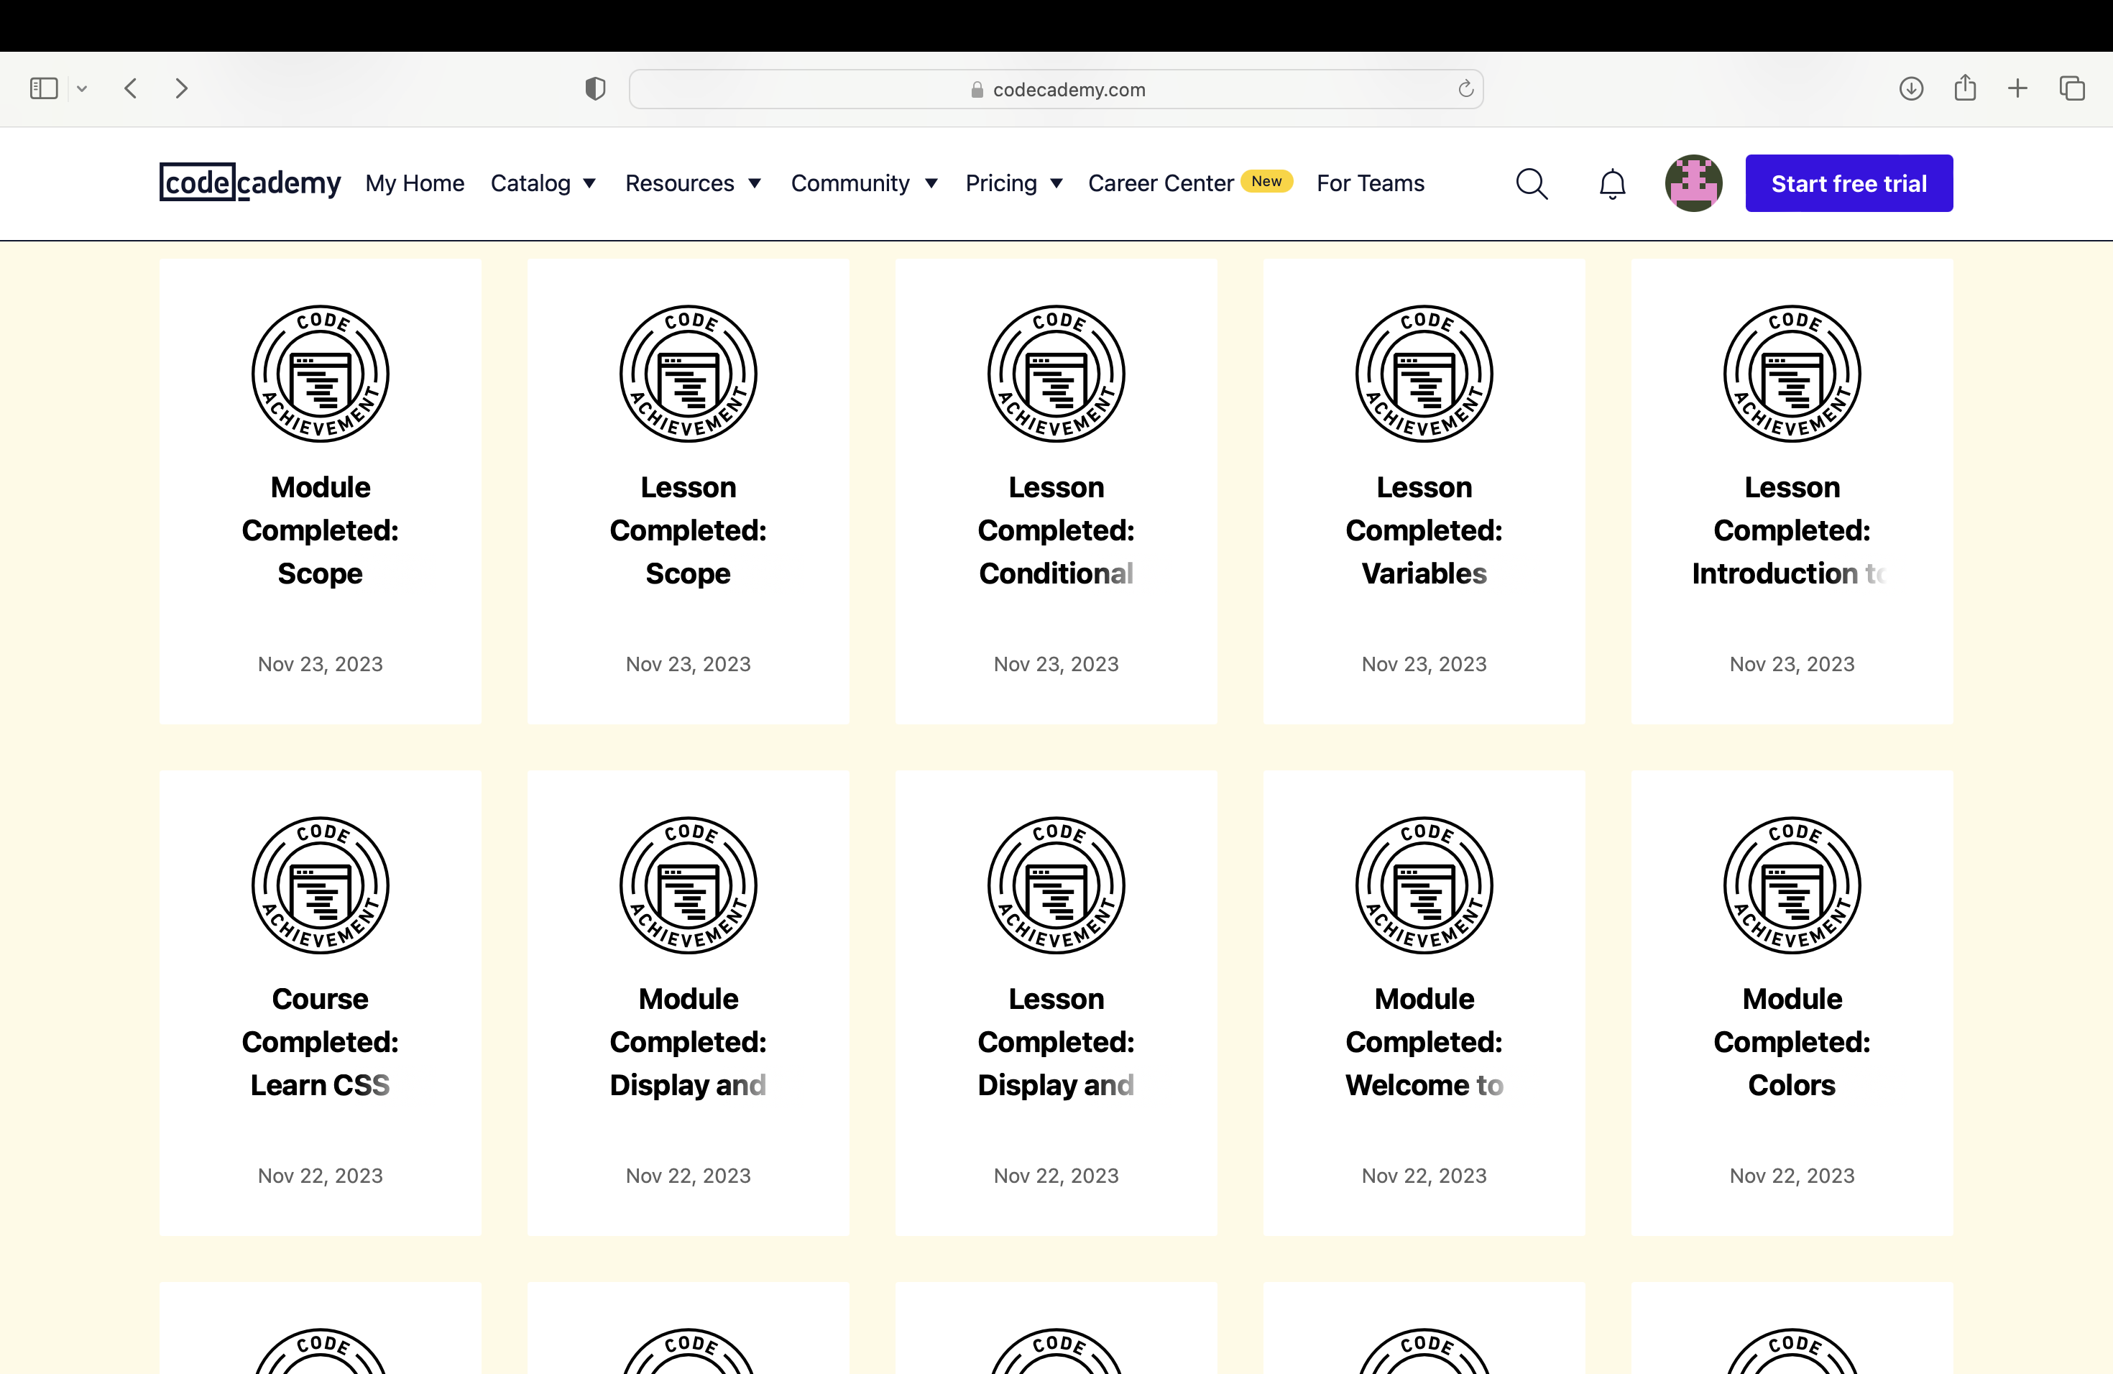

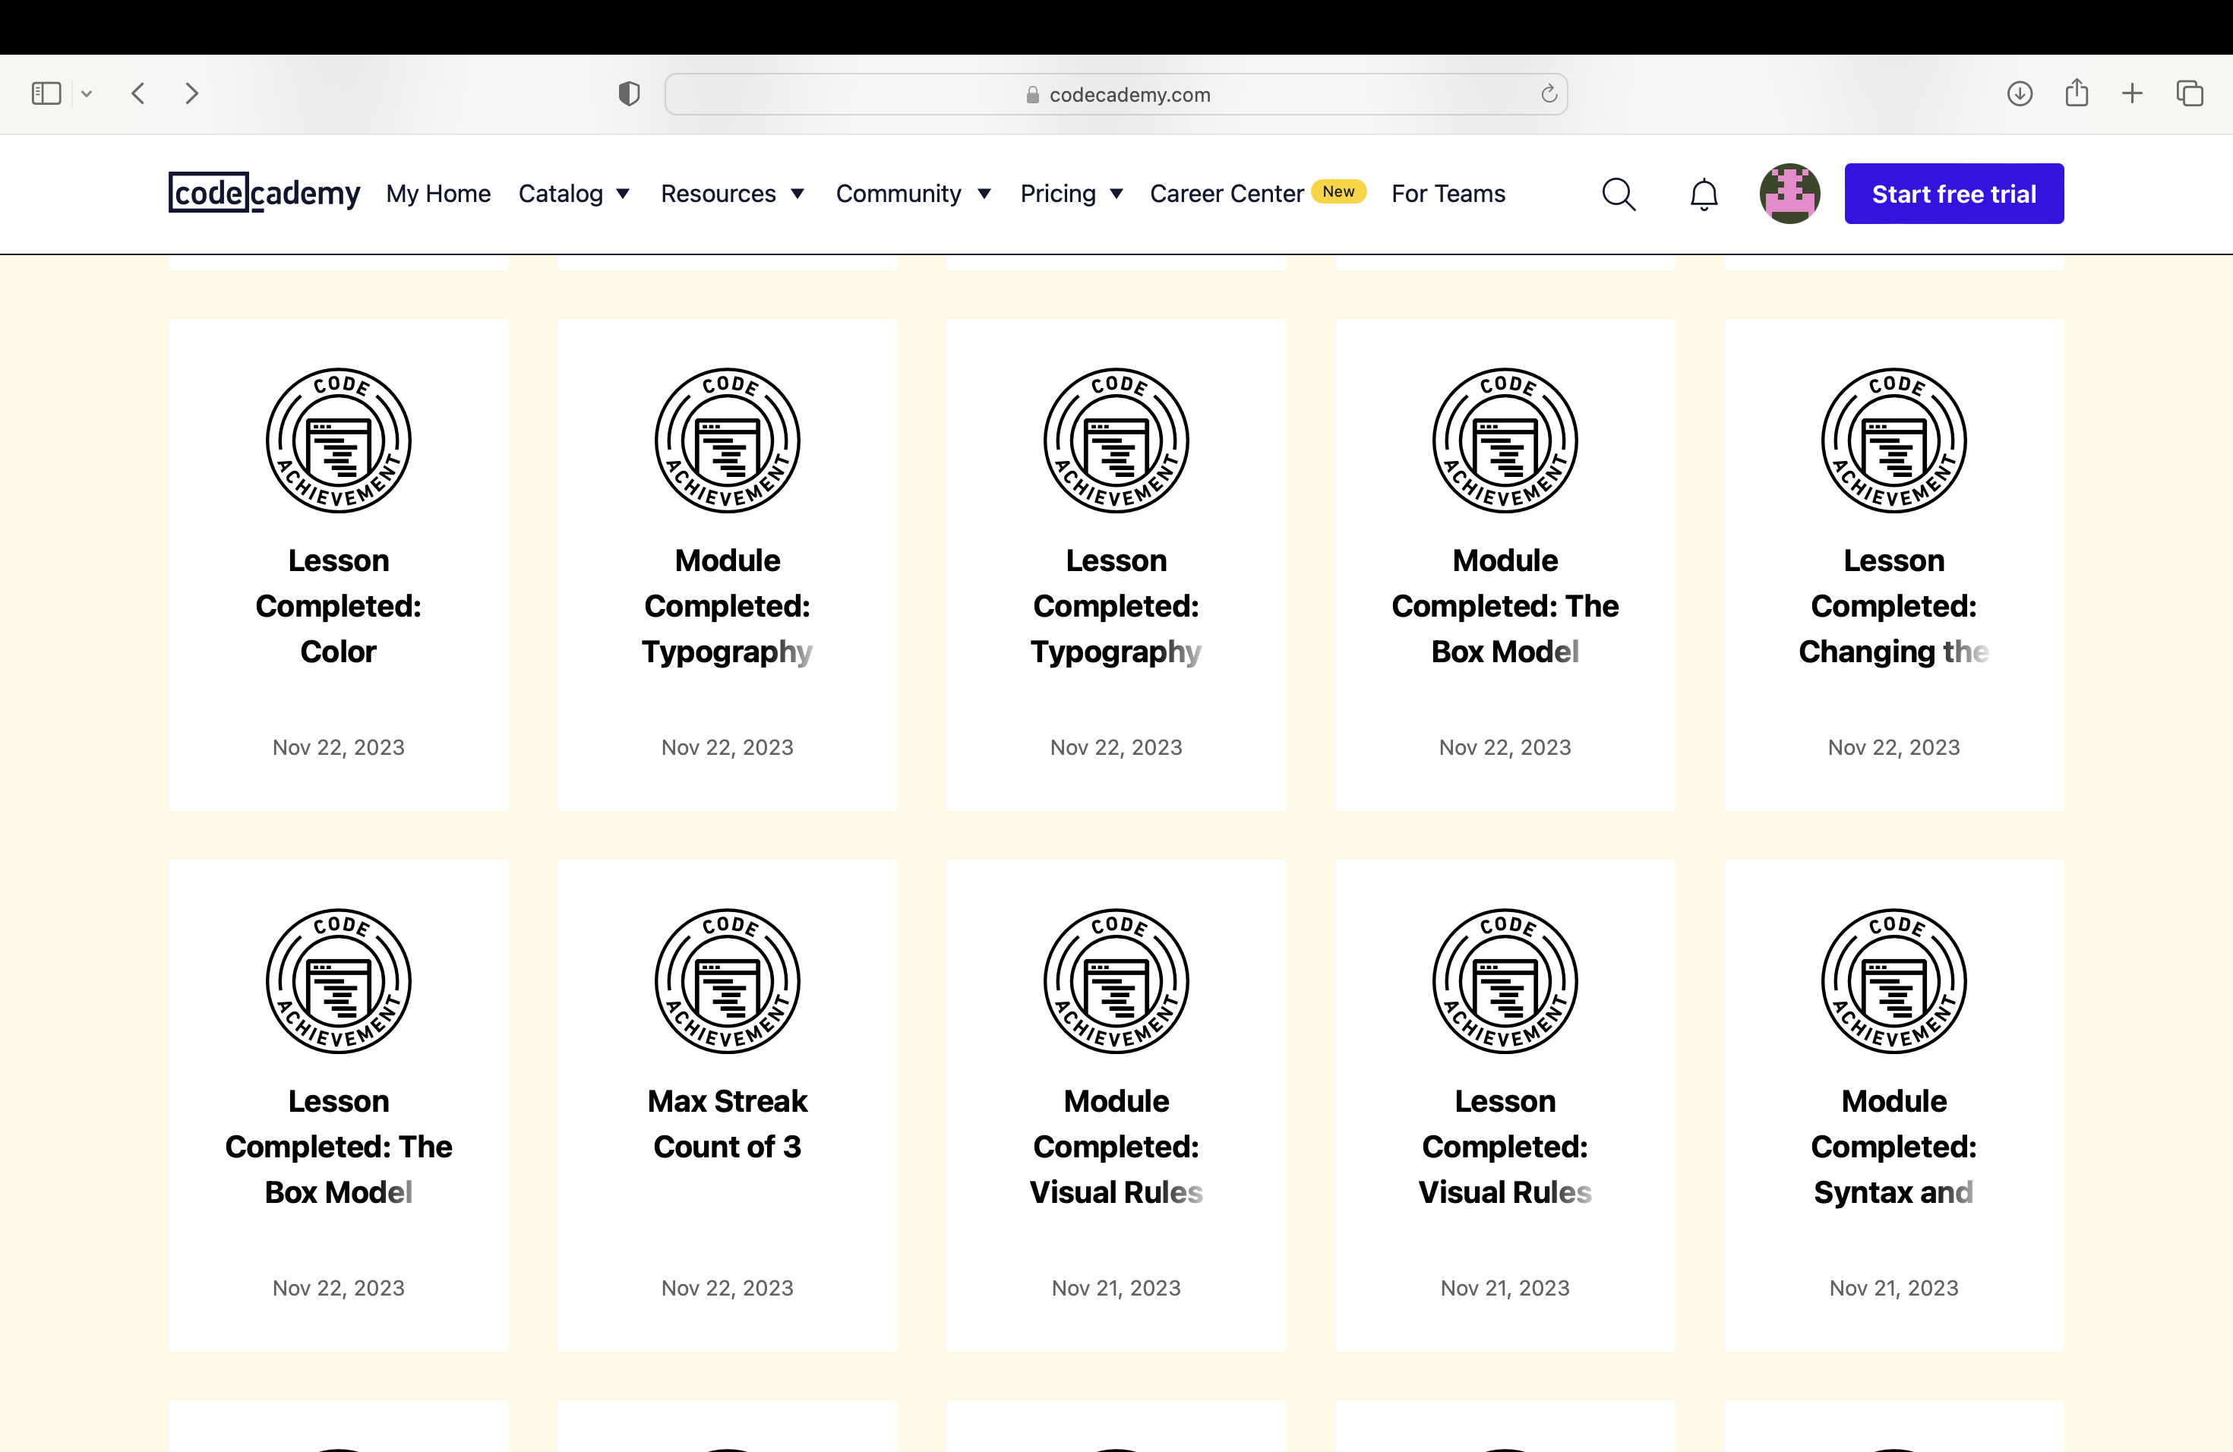

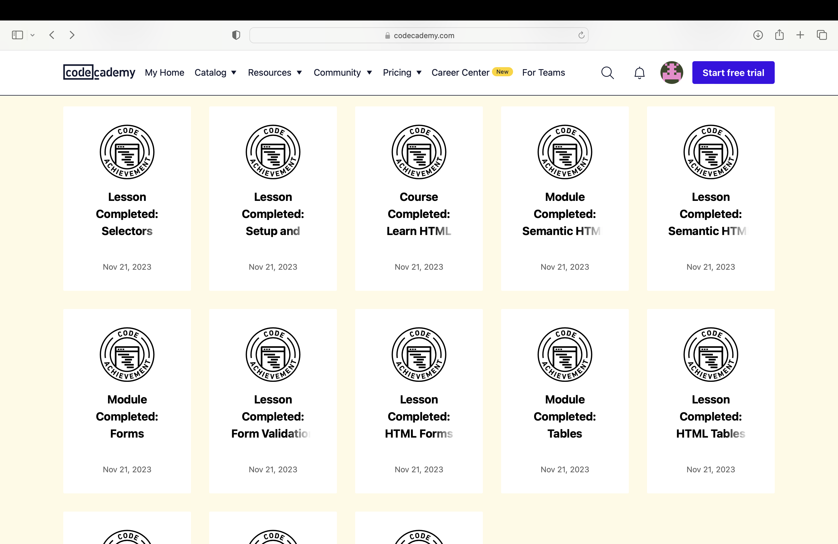

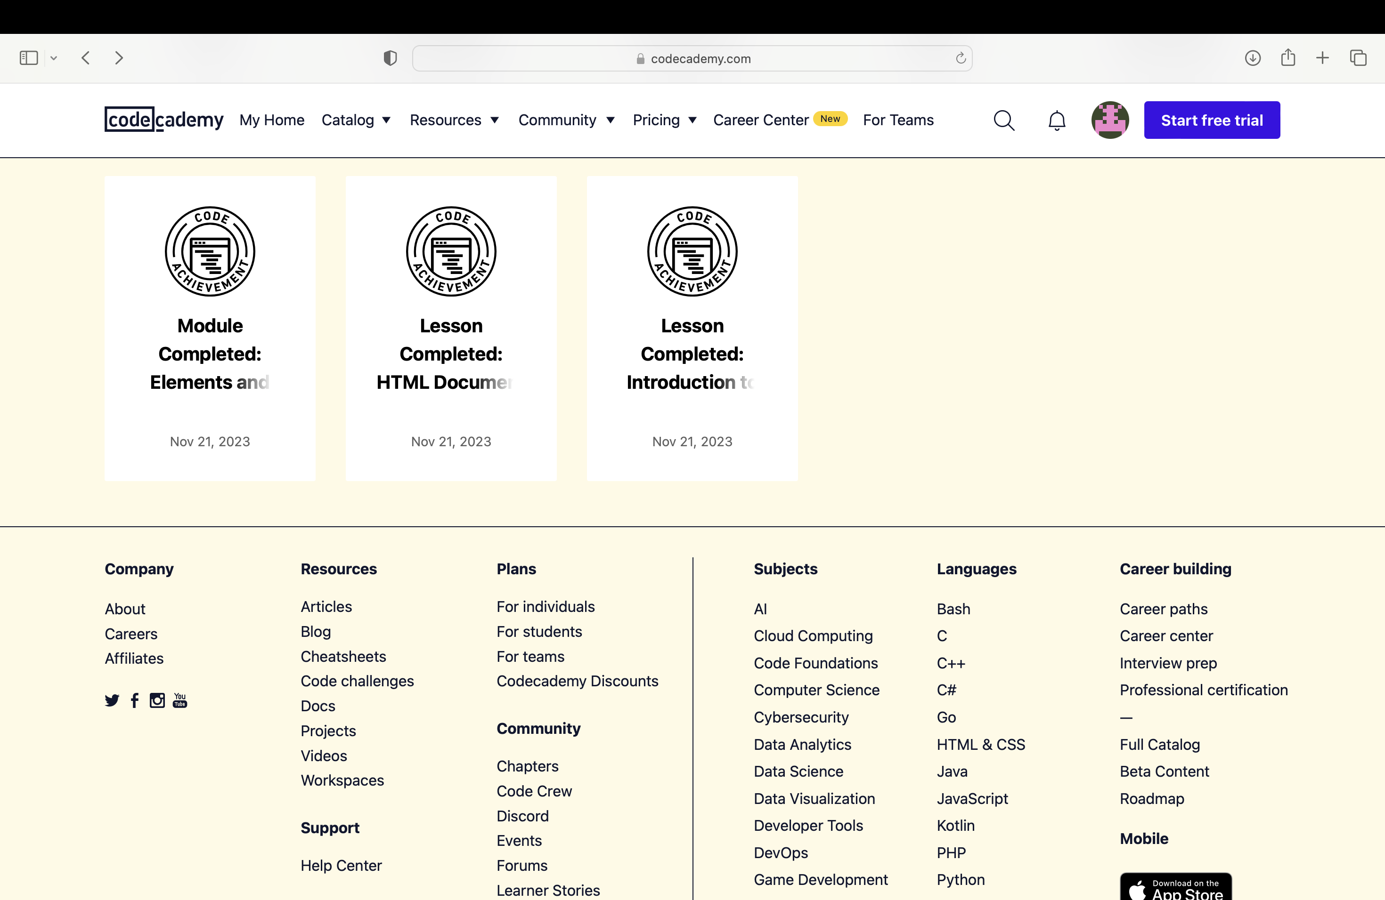

**The URLs of Javid Aghayev**

<https://www.codecademy.com/profiles/JavidAghayev>

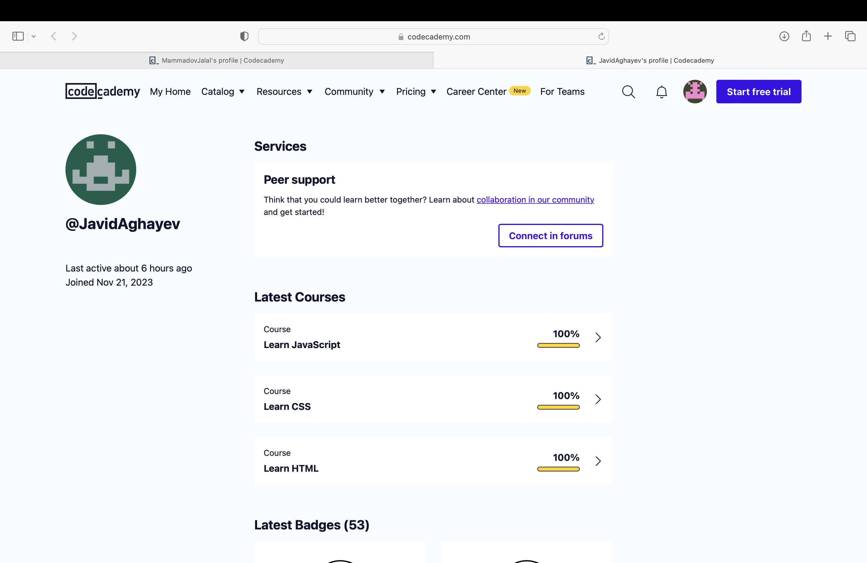

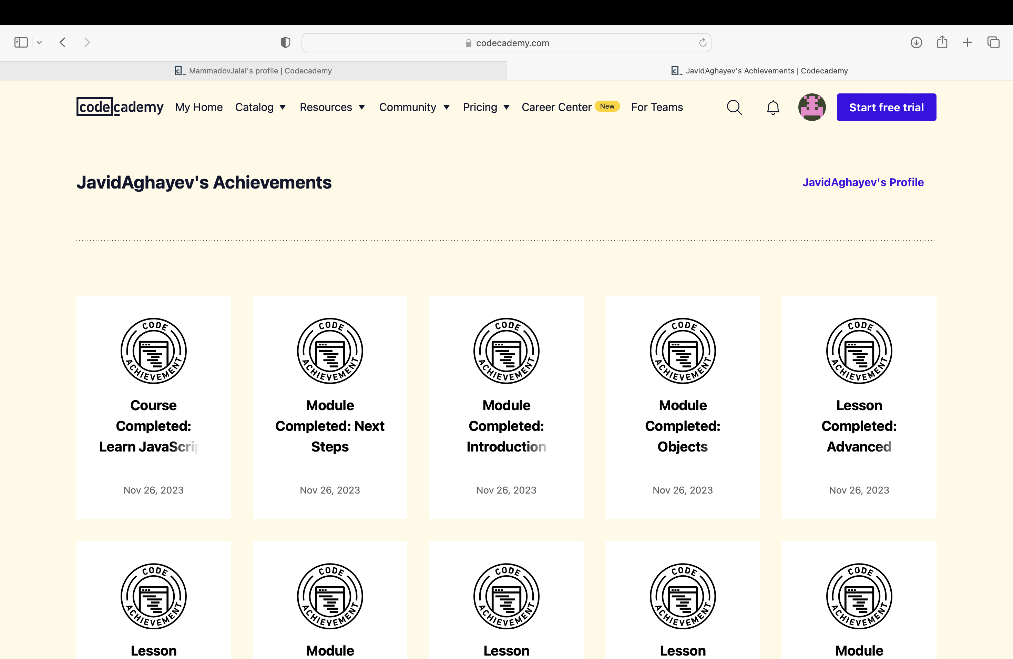

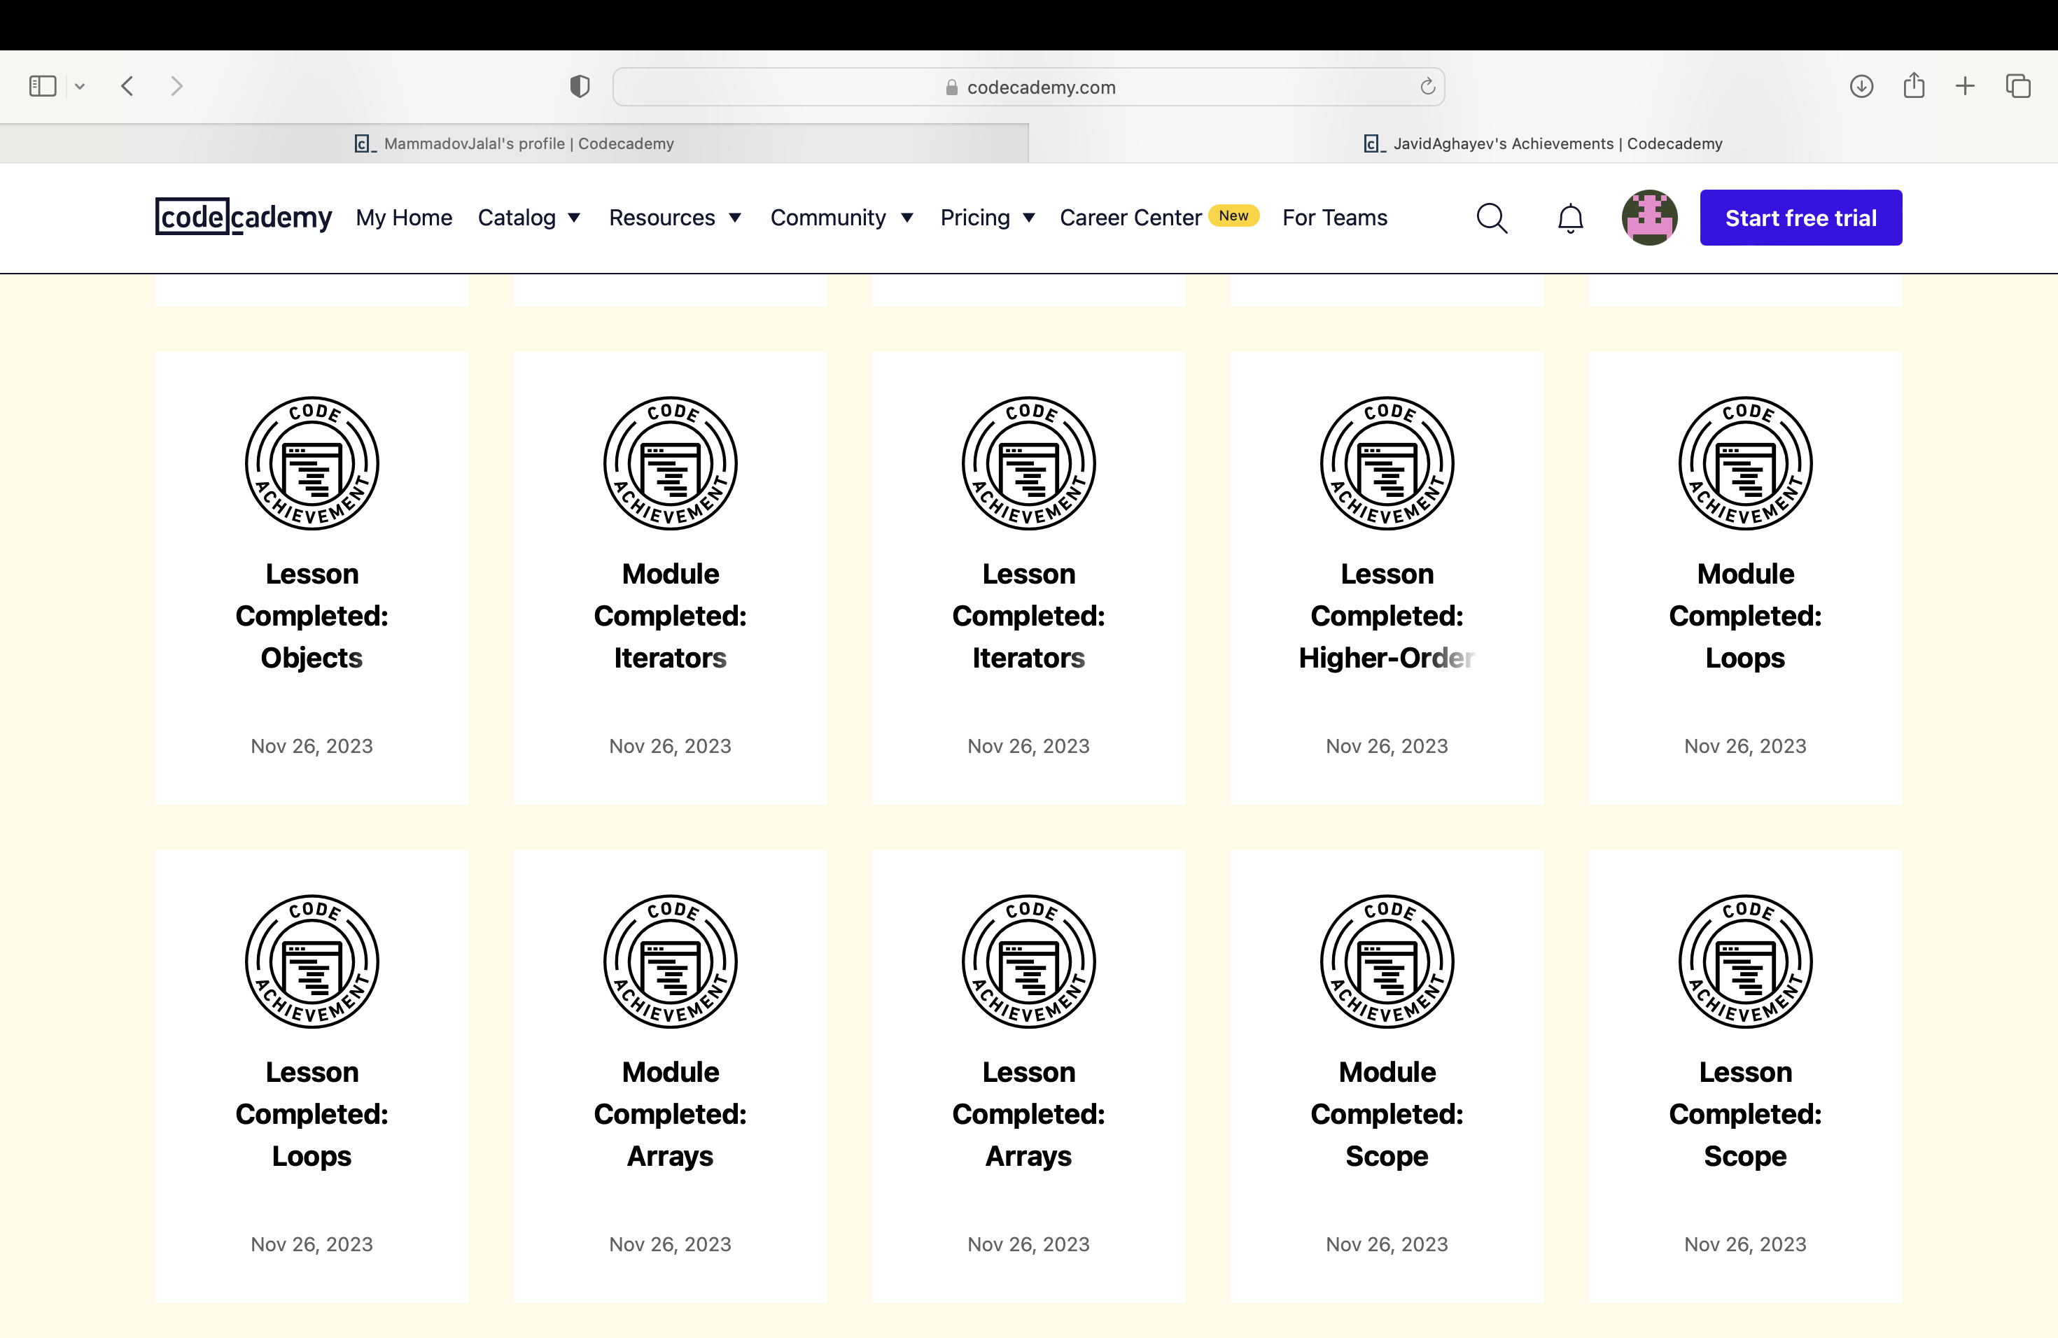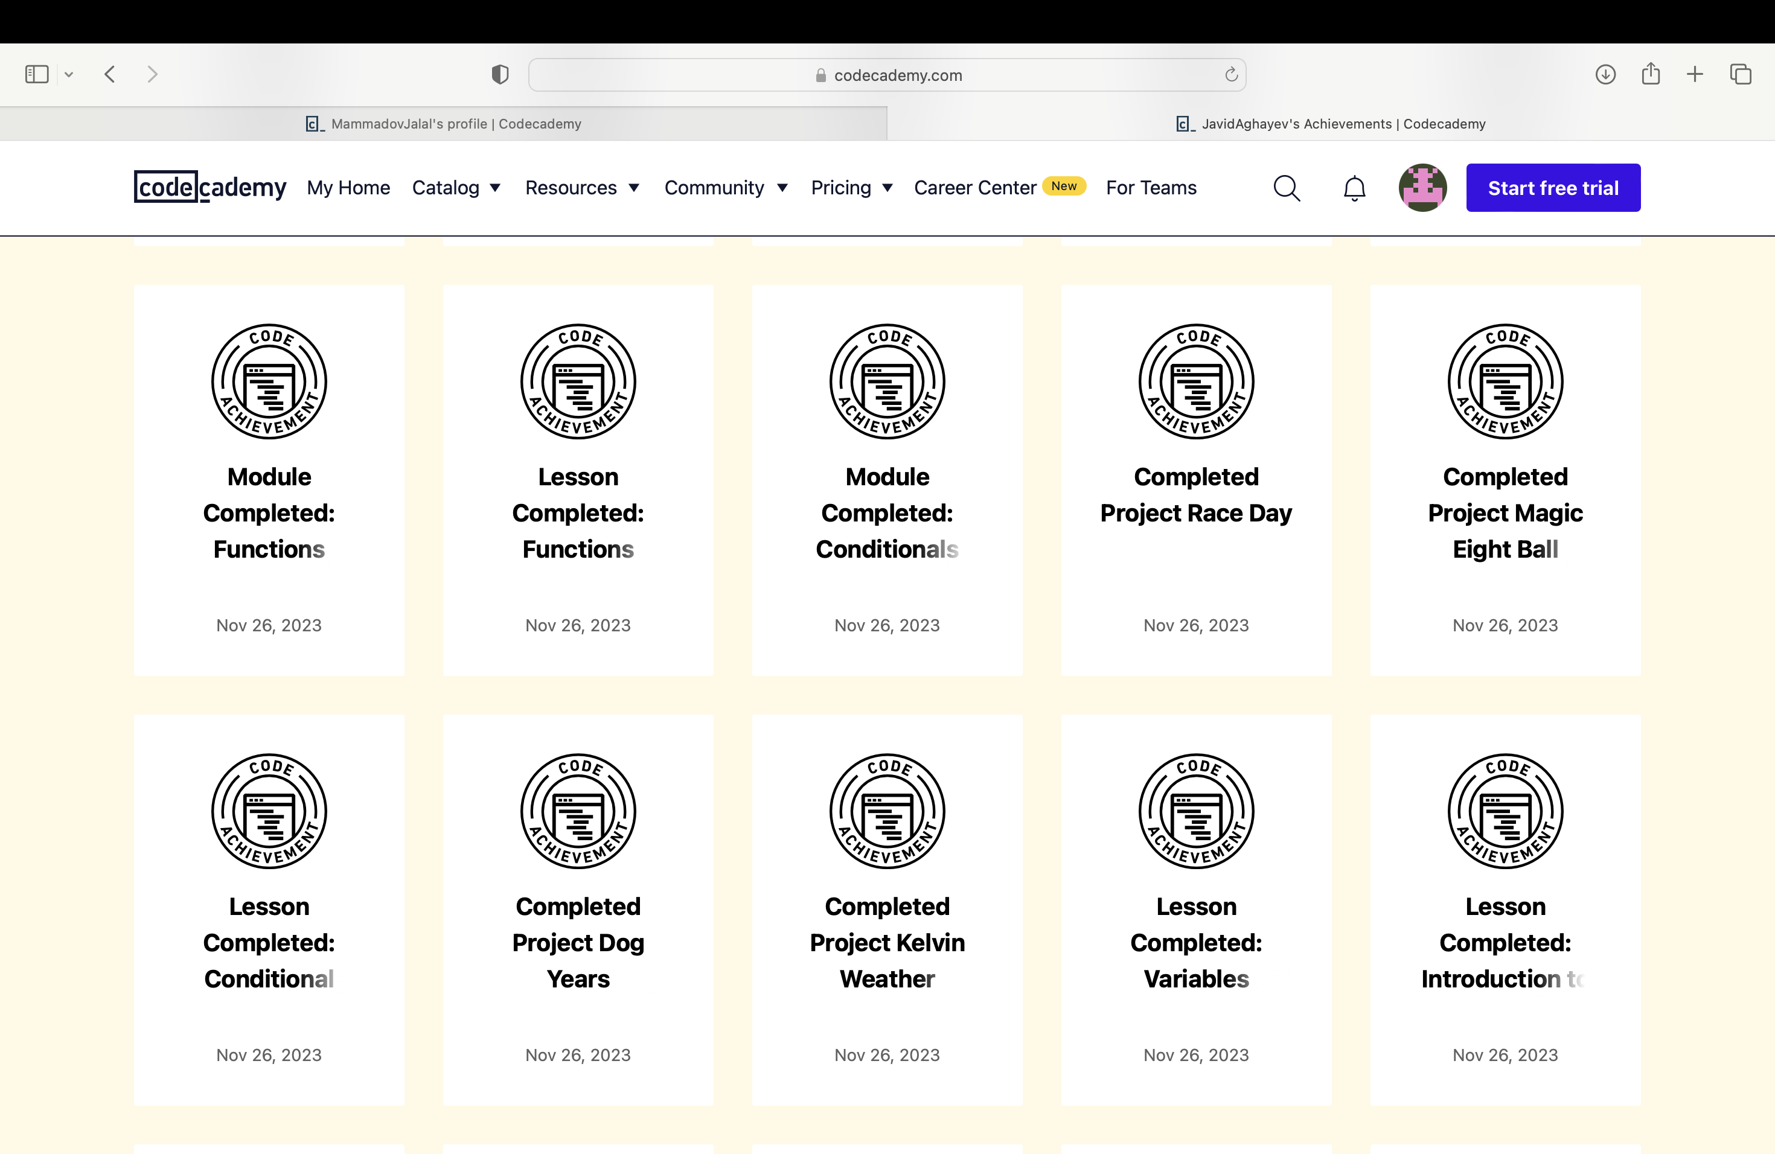

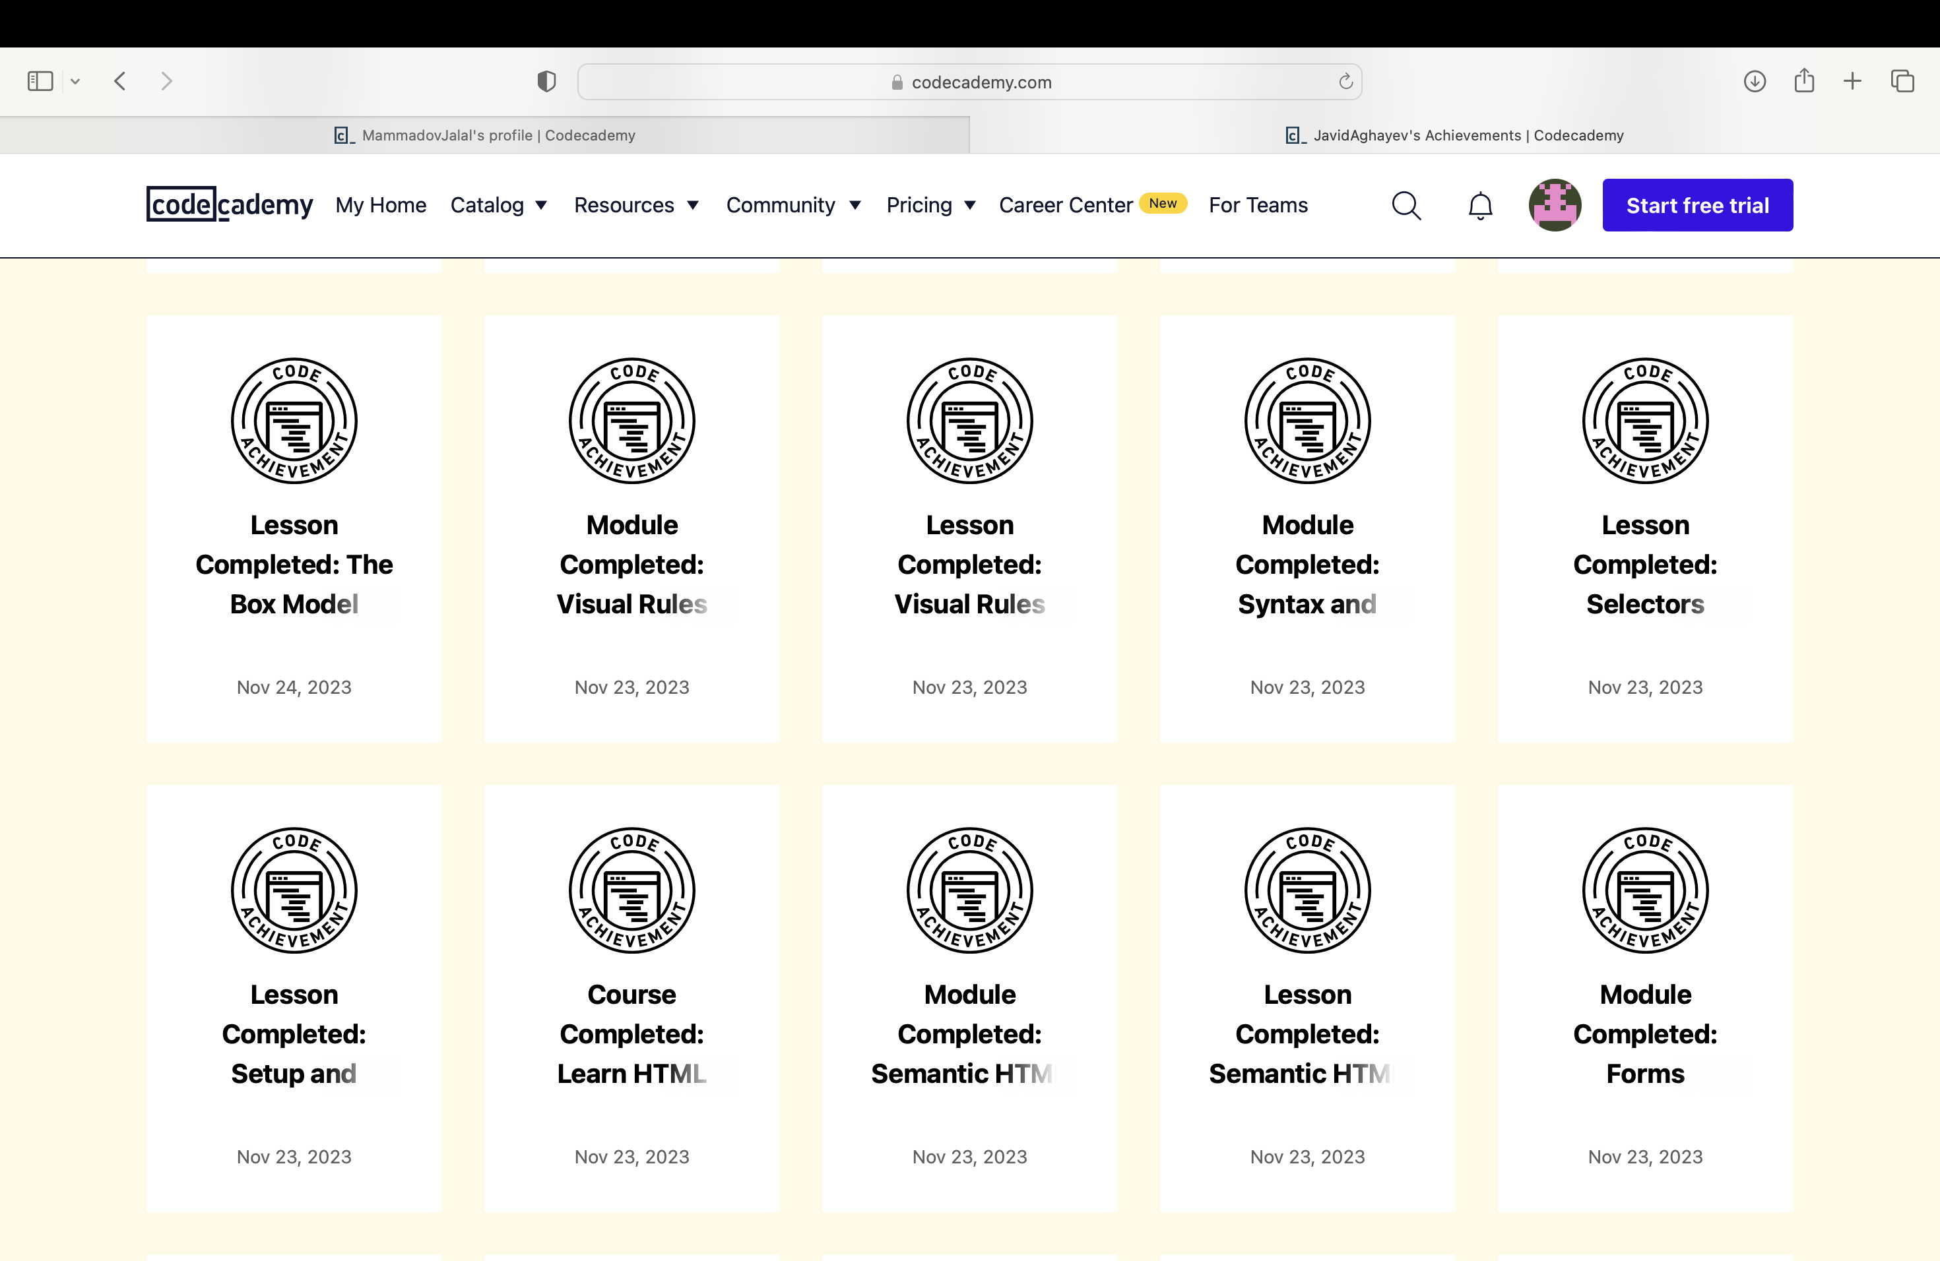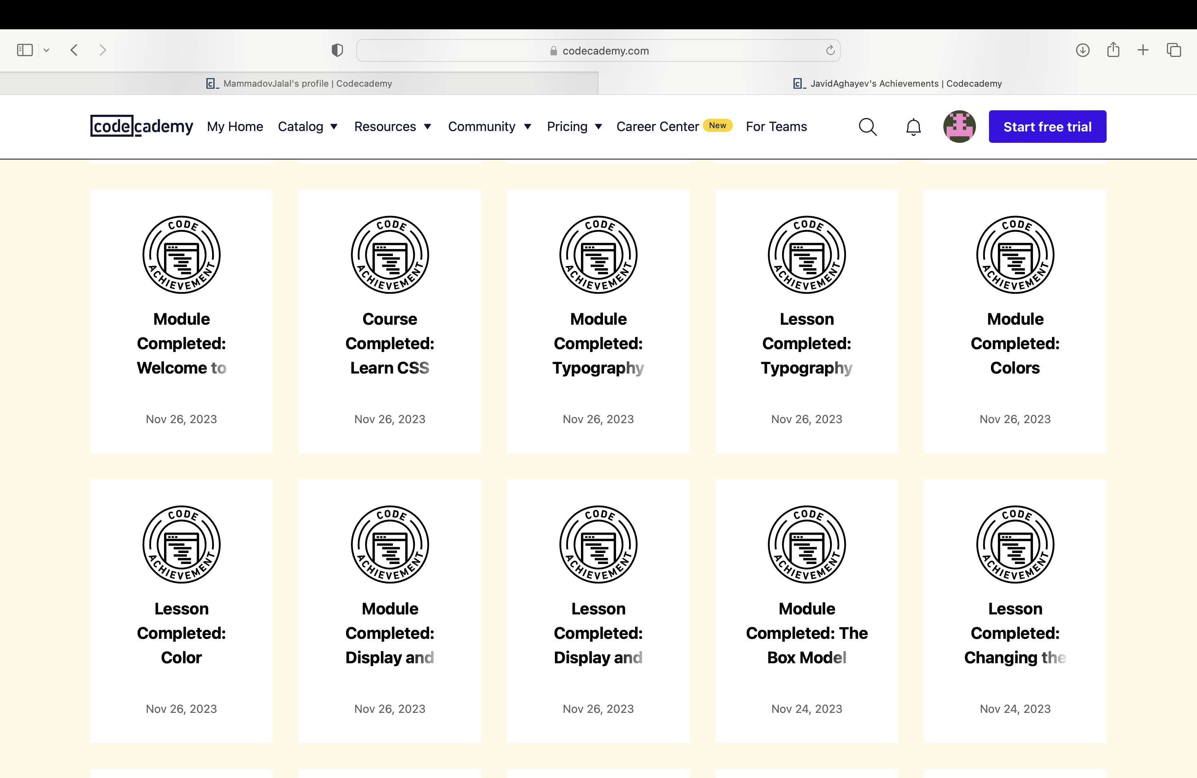

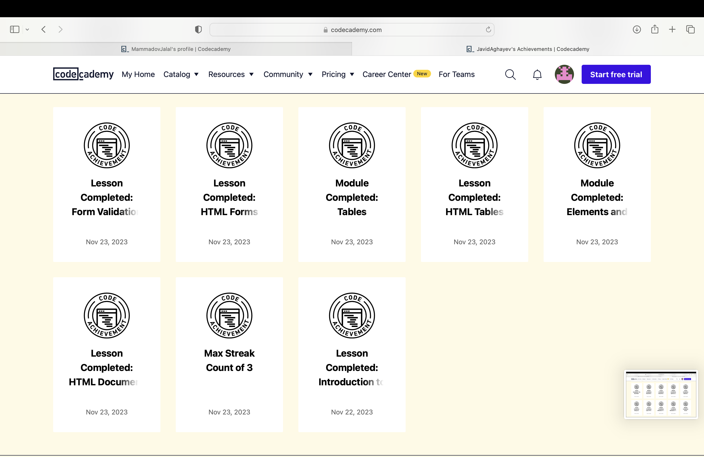

**The URLs of Rüzgar Turhan**

<https://www.codecademy.com/profiles/RuzgarTurhan>

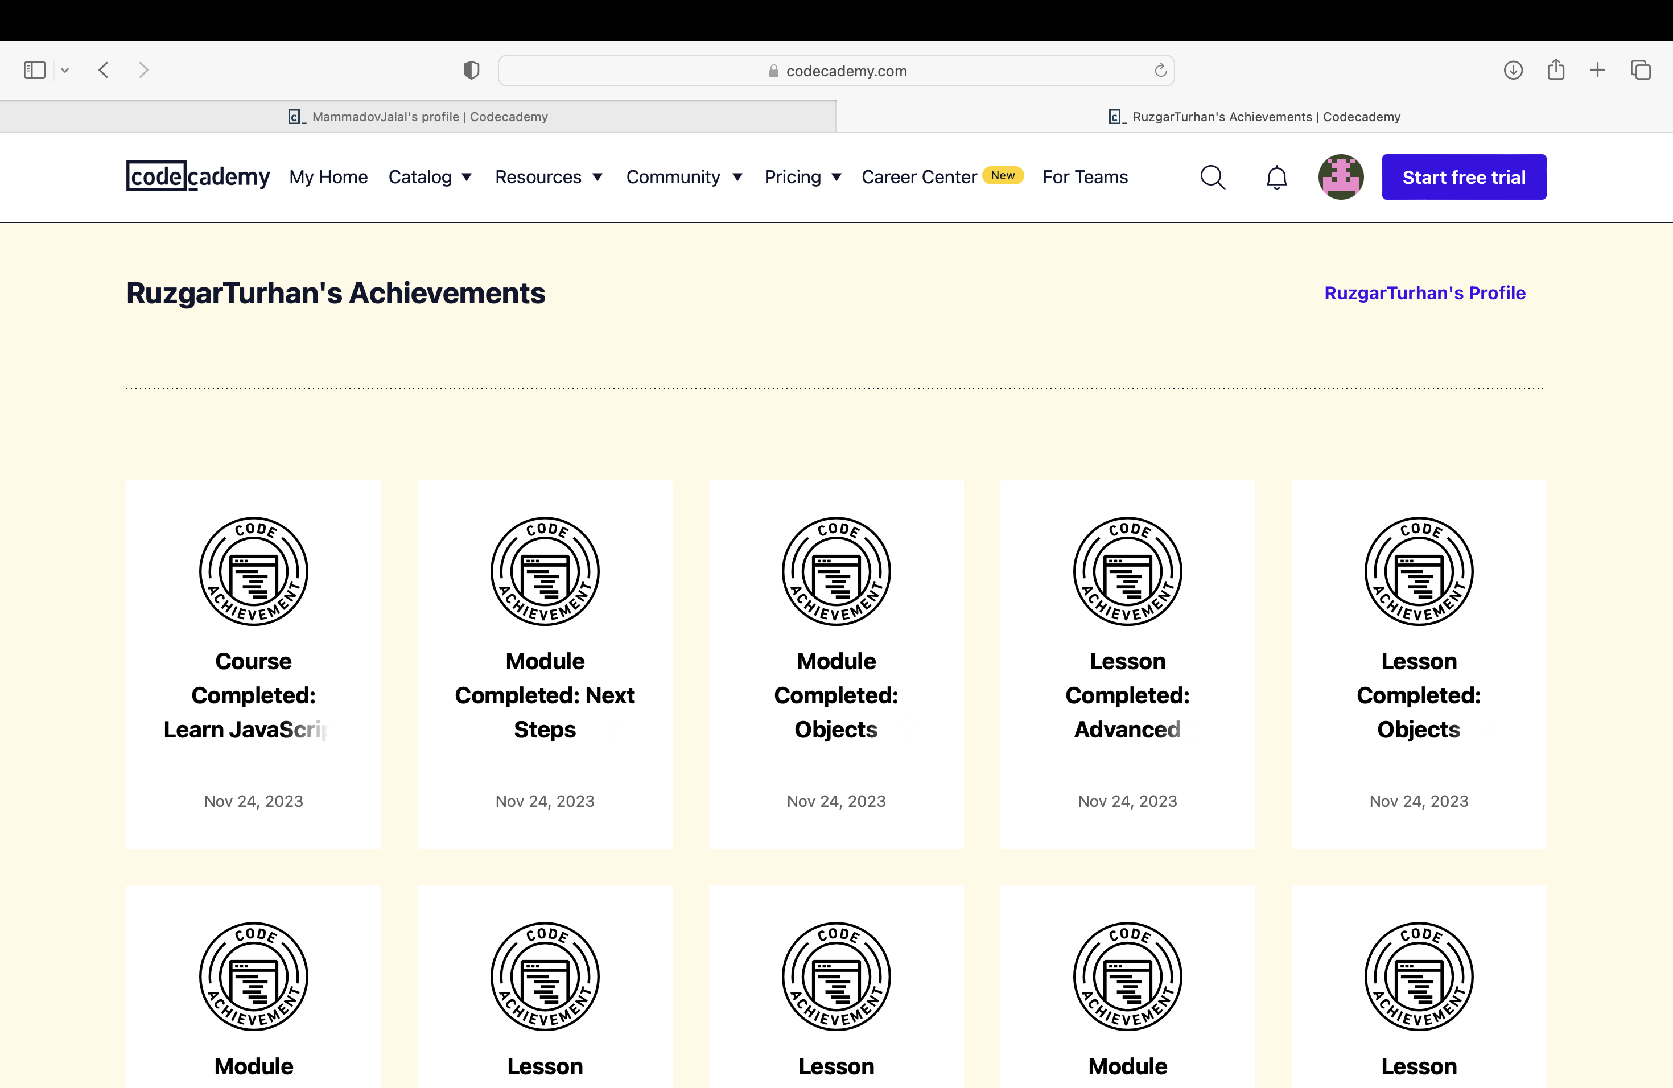

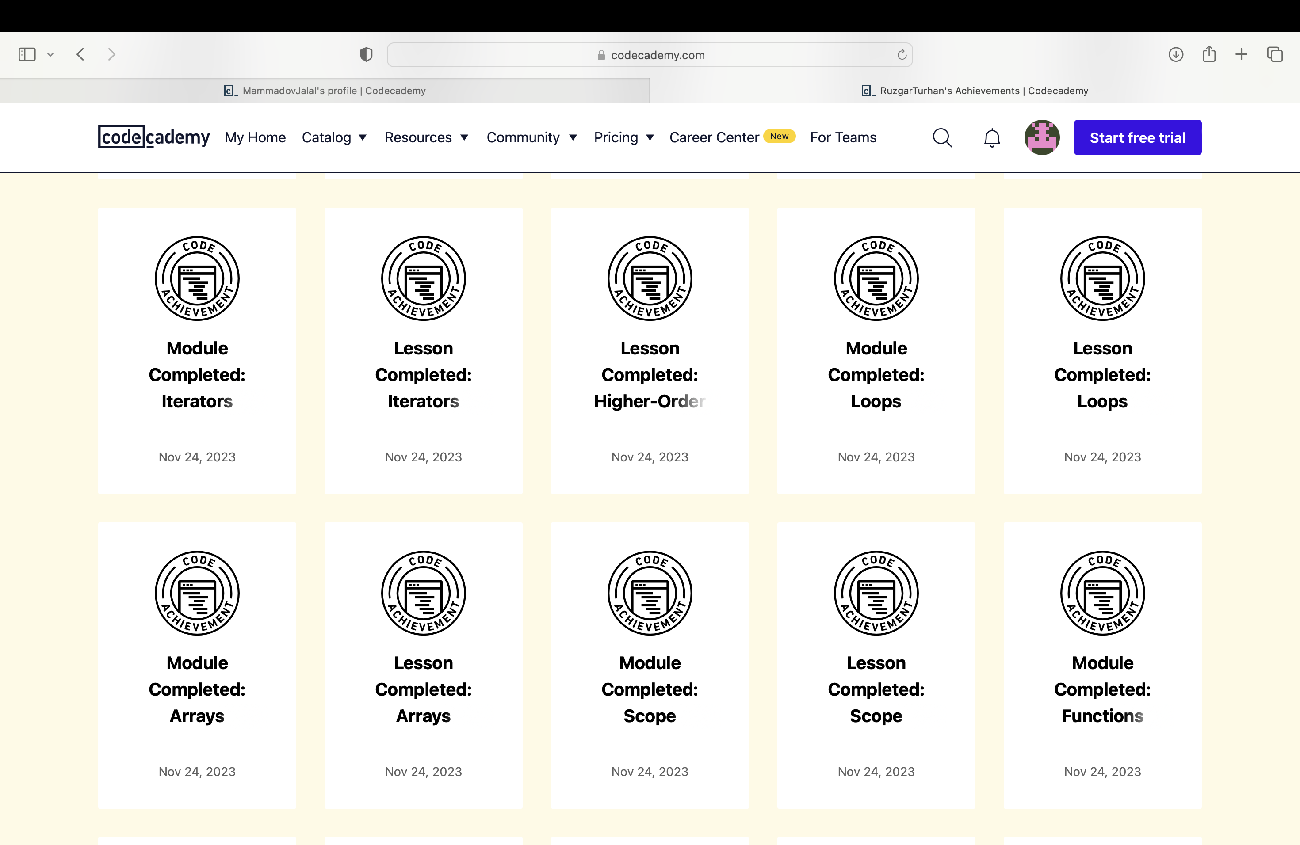

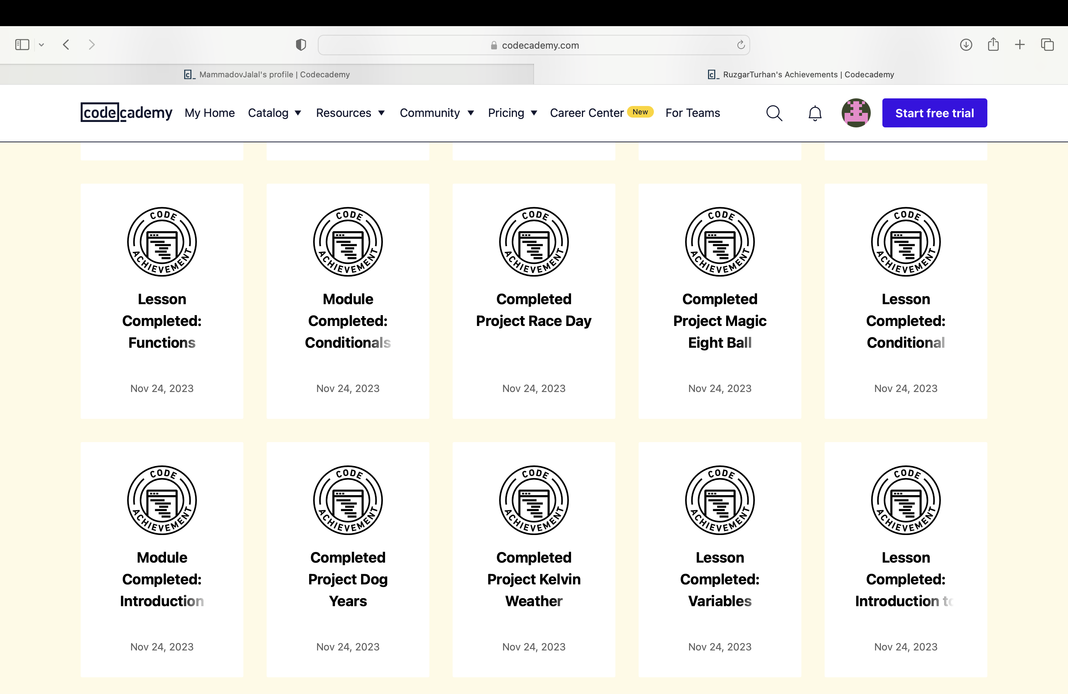

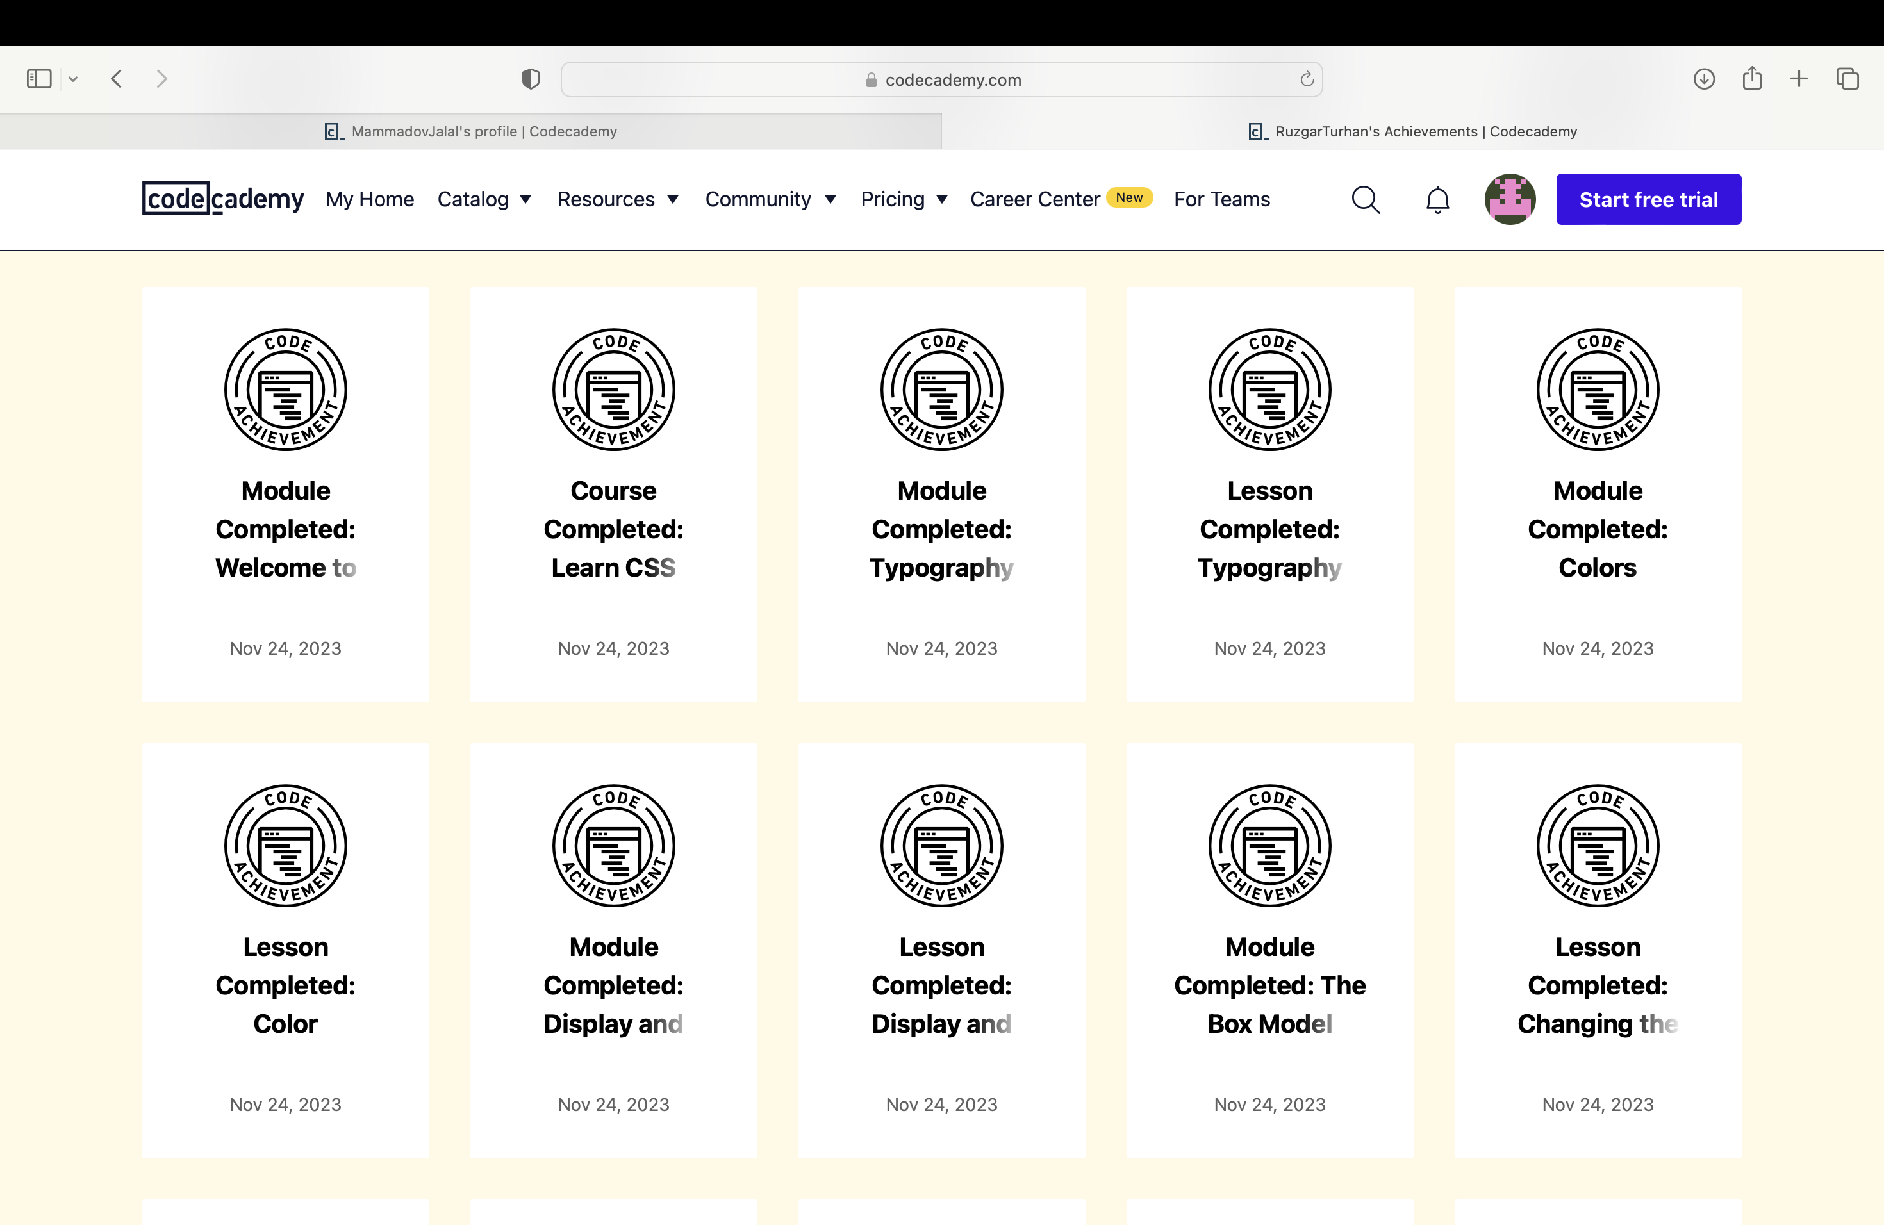

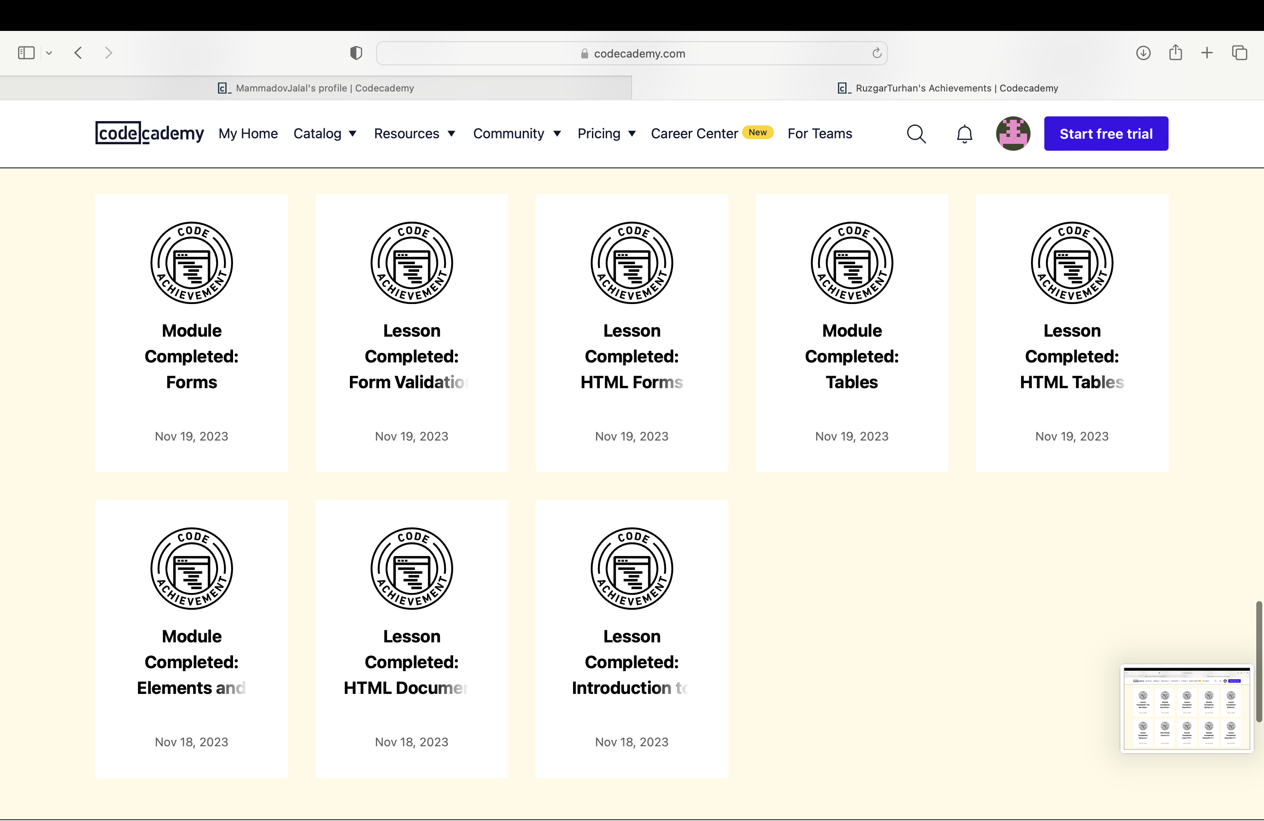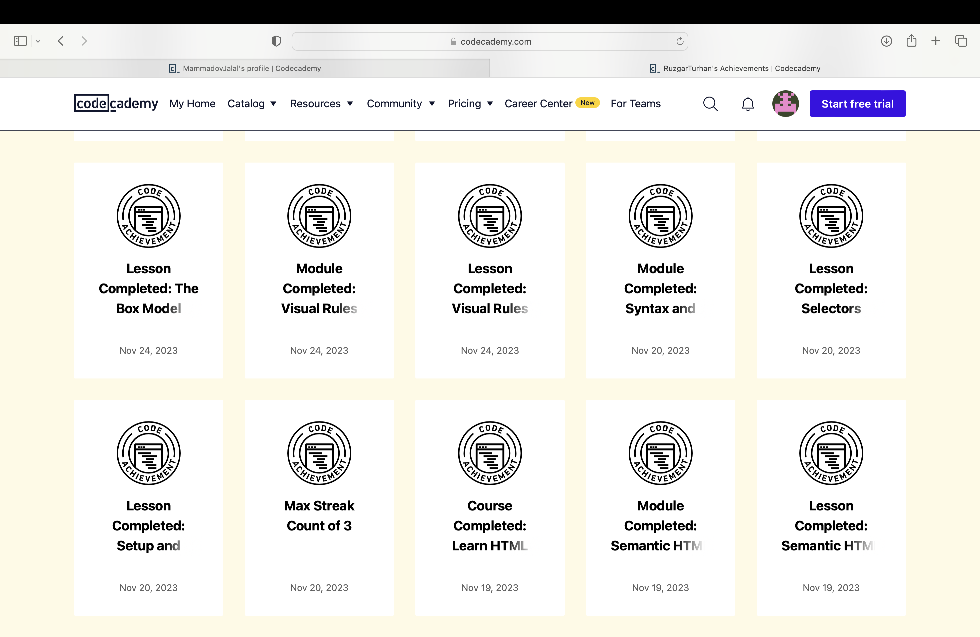

**The URLs of Shukur Ismayilov**

<https://www.codecademy.com/profiles/ShukurIsmayilov>

